**CHAPTER 1**

**INTRODUCTION**

**1. Purpose and Objectives**

* **Promoted environmental awareness** and encouraged **sustainable living**.
* **College students** initiated a campaign to **advocate for paper bags** over plastic.
* Aimed to **reduce plastic consumption** and instill a sense of **environmental responsibility**.

**2. Campaign Setting and Focus**

* **Abbigere, Bangalore**, chosen for its **mix of urban vibrancy and natural beauty**.
* Educated residents about **plastic pollution, soil degradation, and harm to wildlife**.
* Introduced **eco-friendly paper bags** as a **sustainable alternative**.

**3. Addressing Broader Environmental Concerns**

* **Highlighted the importance of afforestation** in maintaining ecological balance.
* Explained how **trees absorb carbon dioxide, improve air quality, and support biodiversity**.
* Distributed **informational materials** to educate the community on tree planting and conservation.

**4. Community Engagement and Participation**

* Actively **interacted with residents** through discussions on sustainability.
* Encouraged **grassroots involvement** to create a **long-term cultural shift** toward sustainability.
* Ensured the message extended **beyond a one-time event**.

**5. Impact and Significance**

* Demonstrated the **power of collective action** in bringing about meaningful change.
* Provided an **immediate alternative to plastic bags** while advocating for **sustainable habits**.
* Set the **foundation for long-term environmental consciousness** in Abbigere.

**6. Contribution to a Sustainable Future**

* Took a stand against **plastic pollution** and emphasized **afforestation**.
* Reinforced the idea that **every action, no matter how small, contributes to sustainability**.
* Represented a step towards a **cleaner, healthier planet** through community-driven efforts.

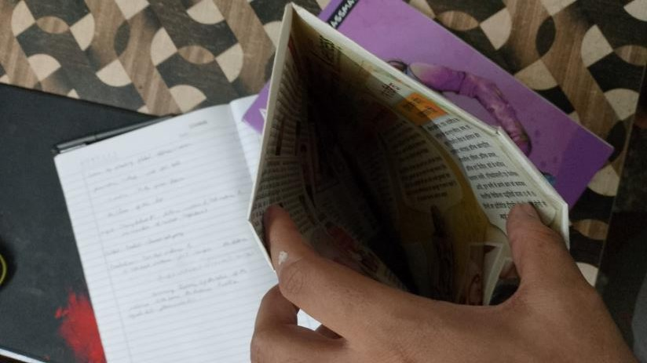 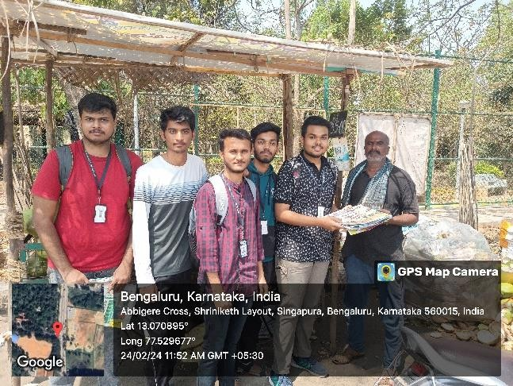

**CHAPTER 2**

**OBJECTIVE**

**1. Paper Bag Distribution – Reducing Plastic Dependency**

* Distributed **eco-friendly paper bags** as a **sustainable alternative** to plastic.
* Aimed to **reduce plastic bag consumption** by making paper bags easily accessible.
* Each paper bag carried **messages promoting sustainable choices and plastic waste reduction**.

**2. Raising Awareness on Plastic Pollution**

* Educated the community about the **harmful environmental effects** of plastic use.
* Highlighted issues such as **land and water pollution, harm to wildlife, and long decomposition times** of plastic waste.
* Used **interactive discussions** to encourage responsible choices and the adoption of biodegradable materials.

**3. Advocating for Afforestation and Ecological Conservation**

* Emphasized the role of **afforestation in climate change mitigation, air quality improvement, and biodiversity support**.
* Distributed **informational pamphlets** explaining the importance of trees in maintaining ecological balance.
* Encouraged residents to **participate in local tree-planting initiatives**.

**4. Encouraging Behavioral Change in the Community**

* Aimed to inspire **a shift in consumer behavior towards sustainability**.
* Promoted **paper bag usage as a normal practice**, reducing reliance on plastic bags.
* Used **consistent messaging and community engagement** to make sustainability a daily habit.

**5. Strengthening Community Engagement and Participation**

* Involved **residents of all ages** to ensure broad participation.
* Created **dialogues on sustainability**, fostering a sense of **shared environmental responsibility**.
* Encouraged **future participation in waste management and afforestation initiatives**.

**6. Establishing a Model for Future Environmental Initiatives**

* Designed to serve as **a blueprint for similar sustainability projects** in other areas.
* Inspired **community-driven environmental efforts** beyond Abbigere.
* Reinforced the **importance of local action in achieving global sustainability goals**.

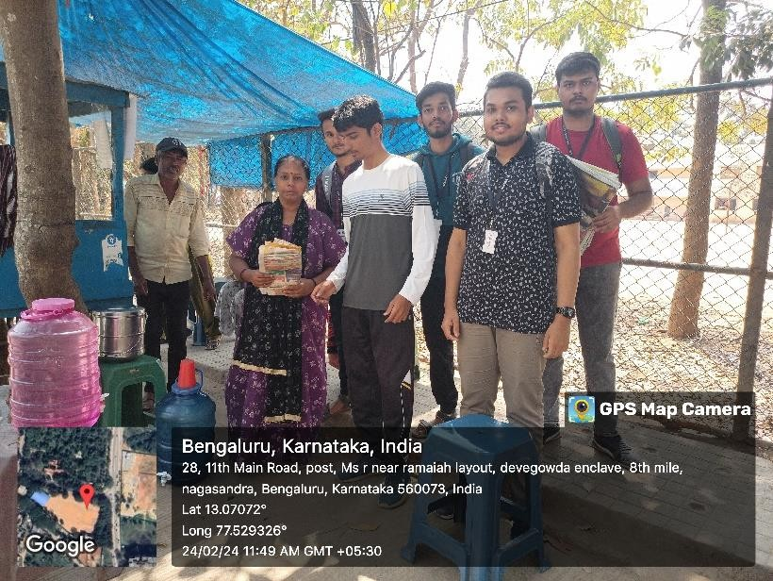

**CHAPTER 3**

**ABOUT THE PLACE**

**1. Geographical and Environmental Aspects**

* **Geographical Location** – Strategically located near **Vidyaranyapura, Jalahalli, and Yeshwanthpur**, ensuring strong connectivity within Bangalore.
* **Climate and Weather** – Experiences a **moderate climate** with **pleasant winters, warm summers, and a monsoon season** that supports greenery.
* **Natural Green Cover** – Despite urbanization, retains **parks, tree-lined streets, and green spaces**, contributing to **clean air and scenic beauty**.

**2. Urbanization and Environmental Concerns**

* **Growing Urbanization** – Rapid population growth and infrastructure development due to proximity to **industrial zones and IT hubs**.
* **Plastic Waste Issue** – Increasing plastic usage and **waste disposal challenges** require sustainable solutions.
* **Afforestation Needs** – Rising construction activities threaten **green cover**, necessitating afforestation efforts for **air quality improvement and ecological balance**.

**3. Community and Lifestyle**

* **Diverse Population** – Home to **working professionals, students, and local business owners**, forming a dynamic community.
* **Local Markets and Businesses** – High plastic usage in **street markets, grocery stores, and small-scale businesses**, emphasizing the need for **paper bag adoption**.
* **Educational Institutions** – Presence of **schools and colleges** makes it an ideal place for **student-led sustainability initiatives**.

**4. Why Abbigere Was Chosen for the Campaign**

* **High Plastic Consumption** – Plastic bags are widely used in **local shops and commercial establishments**, contributing to pollution.
* **Community Engagement Potential** – The **diverse and active population** allows for effective awareness campaigns.
* **Green Preservation Needs** – Urban expansion threatens **existing green spaces**, highlighting the need for afforestation advocacy.
* **Strategic Location** – As a well-connected area, Abbigere can **serve as a sustainability model**, encouraging nearby localities to adopt eco-friendly practices.

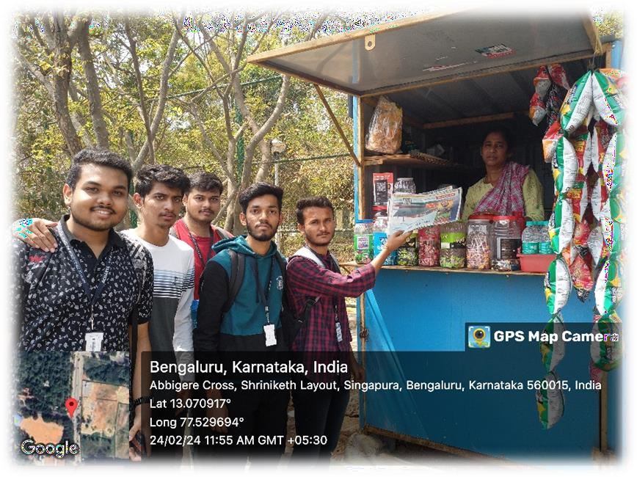

**CHAPTER 4**

**ACTION PLAN**

|  |  |  |  |  |
| --- | --- | --- | --- | --- |
| **SLNO** | **DATE** | **ACTIVITY** | **DURATION** | **REMARKS** |
| 01 | 20-02-2024 | Seeking Permission | 2 | Obtained Permission |
| 02 | 20-02-2024 | Choosing Location | 3 | Found a location |
| 03 | 21-02-2024 | Action plan on materials | 2 | Action plan mapped |
| 04 | 22-02-2024 | Collecting materials | 7 | Materials collected |
| 05 | 23-02-2024 | Collecting materials | 7 | Materials collected |
| 06 | 24-02-2024 | Preparing packages | 7 | Packed prepared |
| 07 | 25-02-2024 | Preparing packages | 7 | Packed prepared |
| 08 | 26-02-2024 | Preparing packages | 2 | Packed prepared |
| 09 | 26-02-2024 | Travelling to reach location | 2 | Reached Location |
| 10 | 26-02-2024 | Distributing packages | 7 | Distributing packages to local vendors |
| 11 | 27-02-2024 | Travelling to reach location | 2 | Reached Location |
| 12 | 27-02-2024 | Distributing packages | 7 | Distributing packages to local vendors |
| 13 | 28-02-2024 | Collecting details and geo tag photos | 3 | Details collected |
| 14 | 28-02-2024 | Making report | 3 | Made report |

**CHAPTER 5**

**CONDUCTION OF THE ACTIVITY**

**1. Planning and Preparation**

**A. Research and Pre-Assessment**

* Conducted **preliminary research** to assess plastic consumption levels.
* Engaged with **local vendors, shopkeepers, and residents** to understand plastic usage and willingness to adopt alternatives.
* Identified the **importance of afforestation** as a complementary sustainability effort.

**B. Resource Collection and Paper Bag Procurement**

* Procured **eco-friendly paper bags** from sustainable sources.
* Designed **informational pamphlets and posters** highlighting plastic pollution and the benefits of paper bags.
* Created **banners and visual materials** for visibility and outreach.

**C. Team Formation and Role Assignment**

Divided participants into specialized teams for efficient execution:

1. **Distribution Team** – Distributed paper bags to vendors, businesses, and residents.
2. **Awareness Team** – Educated the community on plastic pollution and sustainable practices.
3. **Documentation Team** – Captured photographs, videos, and testimonials.
4. **Afforestation Advocacy Team** – Promoted tree planting and environmental conservation efforts.

**2. Execution of the Activity**

**A. Paper Bag Distribution Drive**

* Distributed **eco-friendly paper bags** in **marketplaces, grocery stores, and residential areas**.
* Each paper bag carried an **environmental awareness message**.
* Encouraged **shopkeepers to replace plastic bags** with paper alternatives.

**B. Community Engagement and Awareness Campaign**

* Conducted **door-to-door campaigns** to discuss the environmental impact of plastic.
* Organized **educational sessions** on pollution, soil degradation, and marine life impact.
* Explained **health hazards** associated with plastic use, promoting safer alternatives.

**C. Afforestation Awareness and Environmental Pledges**

* Distributed **pamphlets on afforestation and climate change** mitigation.
* Encouraged residents to take **afforestation pledges** and plant trees.
* Educated the community on **air purification, biodiversity, and combating climate change**.

**D. Public Display and Promotional Efforts**

* Displayed **posters and banners** in high-traffic areas.
* Volunteers **wore eco-friendly slogan t-shirts** to spark conversations and increase awareness.

**3. Response and Community Feedback**

**A. Positive Reception and Behavioral Change**

* Residents **welcomed the initiative**, with many pledging to **reduce plastic use**.
* Several **shopkeepers agreed to permanently switch to paper bags**.
* Increased community awareness of **sustainable practices**.

**B. Afforestation Interest and Commitment**

* Many residents **expressed interest in tree-planting programs**.
* Some pledged to **maintain and protect local green spaces**.

**4. Challenges Faced During Execution**

**A. Behavioral Resistance**

* Some residents **hesitated to change habits** and adopt paper bags.
* Shopkeepers **worried about cost and durability** compared to plastic bags.

**B. Limited Awareness**

* Some community members **lacked basic environmental knowledge**, requiring simplified messaging.

**C. Communication Barriers**

* Language differences made engagement difficult in **Abbigere’s diverse population**.
* Volunteers used **bilingual pamphlets and local language interactions** for better outreach.

**D. Long-Term Commitment Concerns**

* Ensuring **continued paper bag usage** required **follow-up initiatives**.
* Suggested **collaboration with local authorities and environmental groups** for sustained impact.



**OUTCOMES**

**Paper Bag Promotion Campaign in Abbigere**

* **More than just an environmental initiative** – it was a **movement towards change, awareness, and responsibility**.
* **Community engagement, education, and participation** played a key role in driving sustainable habits.
* Witnessed a **cultural shift** from **plastic dependence to eco-friendly choices**.
* Residents embraced **paper bags and afforestation efforts**, proving that **awareness leads to action**.
* Sustainability requires **continuous commitment**—the **seeds of change** will only grow with **perseverance and responsibility**.
* Hope to **inspire other communities** to take charge of their environment through **small yet meaningful steps**.
* The campaign was not just about **replacing plastic with paper**, but about **reshaping mindsets, restoring nature, and reclaiming the future**.

**Key Takeaways from the Initiative**

1. **Reduction in Plastic Usage**
   * Introduced **paper bags as an alternative to plastic**.
   * Encouraged **residents and shopkeepers** to switch to **eco-friendly options**.
2. **Increased Awareness**
   * Educated the community on **the harmful effects of plastic pollution**.
   * Highlighted the **benefits of biodegradable materials like paper bags**.
3. **Afforestation Advocacy**
   * Promoted **tree planting and environmental conservation**.
   * Inspired residents to **take afforestation pledges** for a greener future.
4. **Community Engagement**
   * Strengthened the **bond between people and nature**.
   * Fostered **collective responsibility for environmental preservation**.
5. **Behavioral Shift**
   * Overcame **initial resistance** to adopting **eco-friendly habits**.
   * Demonstrated how **persistence and education** can lead to **lasting change**.